**Name**

**Advanced Programming in Java**

**Lab Exercise 1/9/2020**

Your task today is to create a bowling simulator that will score 4 players. The player’s scores will be stored in disk files named “one.txt”, “two.txt”, “three.txt”, and “four.txt”.

Use the following score sheet to aid you in building your text files.

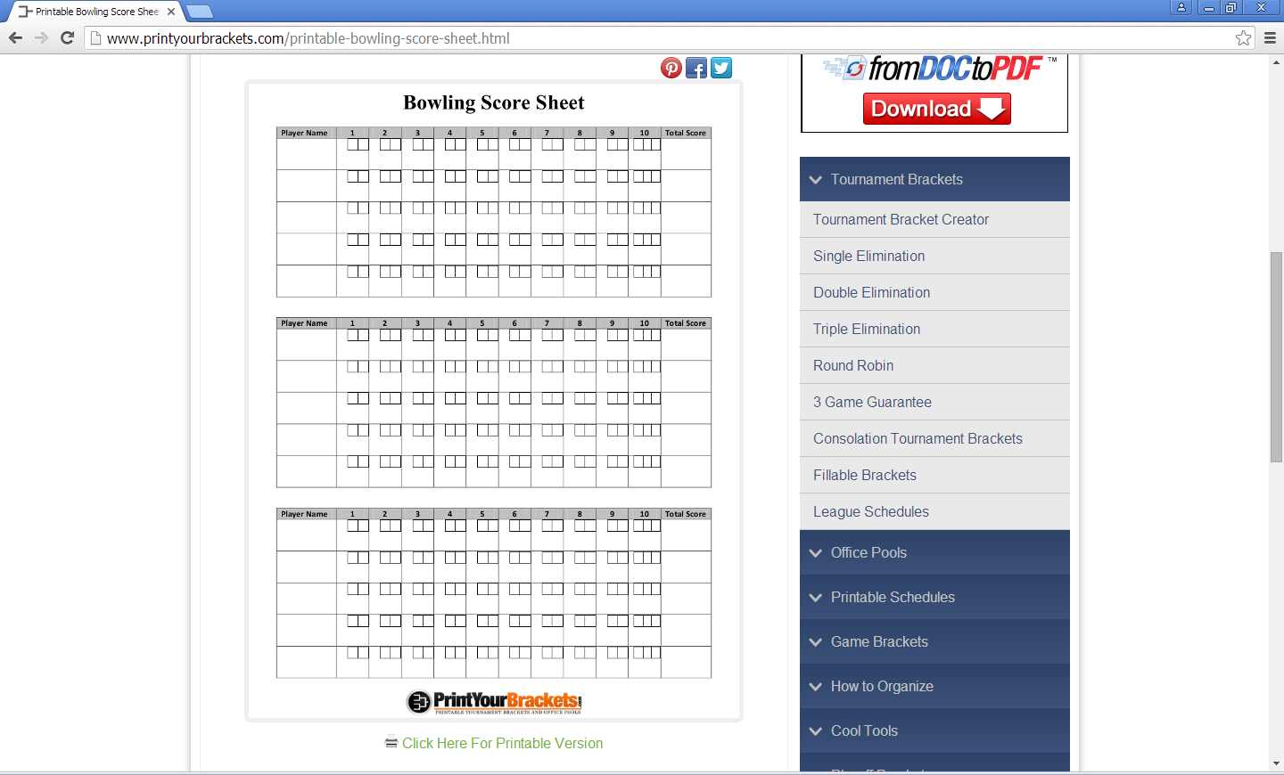

Your output should resemble this:

Player 1 score

Frame

1 2 3 4 5 6 7 8 9 10

9 12 19 25 30 39 53 59 67 76

Player 2 score

Frame

1 2 3 4 5 6 7 8 9 10

8 14 21 30 39 48 62 67 87 104

Player 3 score

Frame

1 2 3 4 5 6 7 8 9 10

7 24 33 40 58 66 81 101 120 129

Player 4 score

Frame

1 2 3 4 5 6 7 8 9 10

20 46 65 74 92 101 129 149 167 186

When you have completed the project, print your source code and a printout of your output, attach to this sheet and turn in.